CONFERENCE MANAGEMENT SYSTEM

USECASE DIAGRAM:

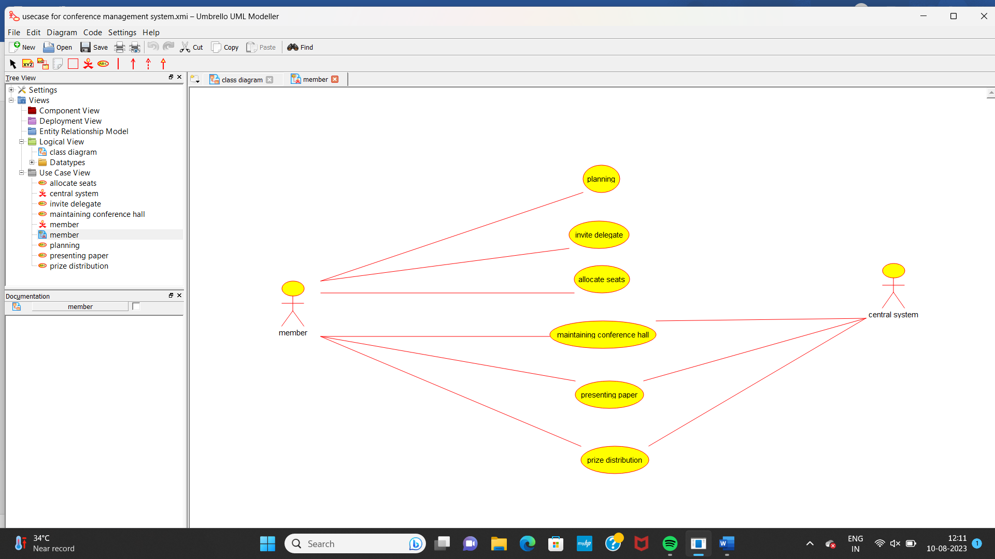

CLASS DIAGRAM:

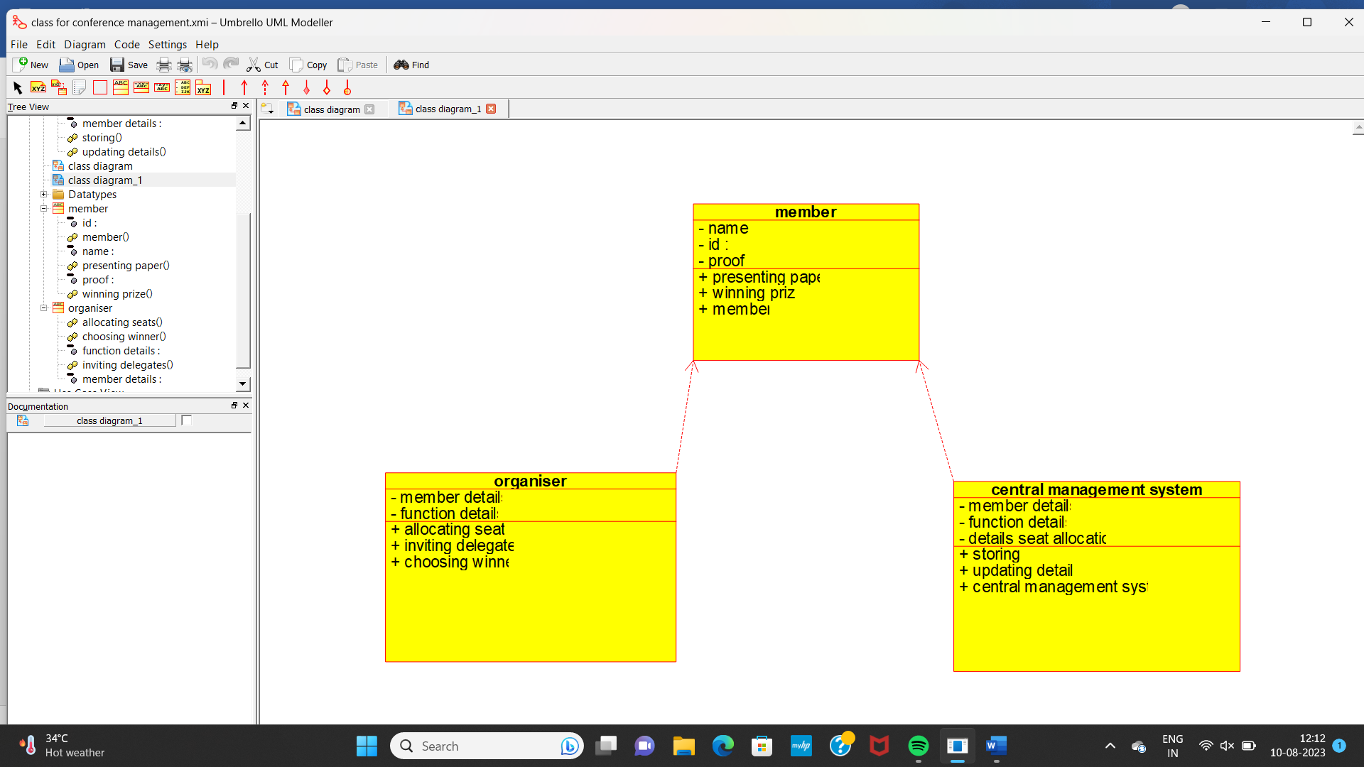

ACTIVITY DIAGRAM:

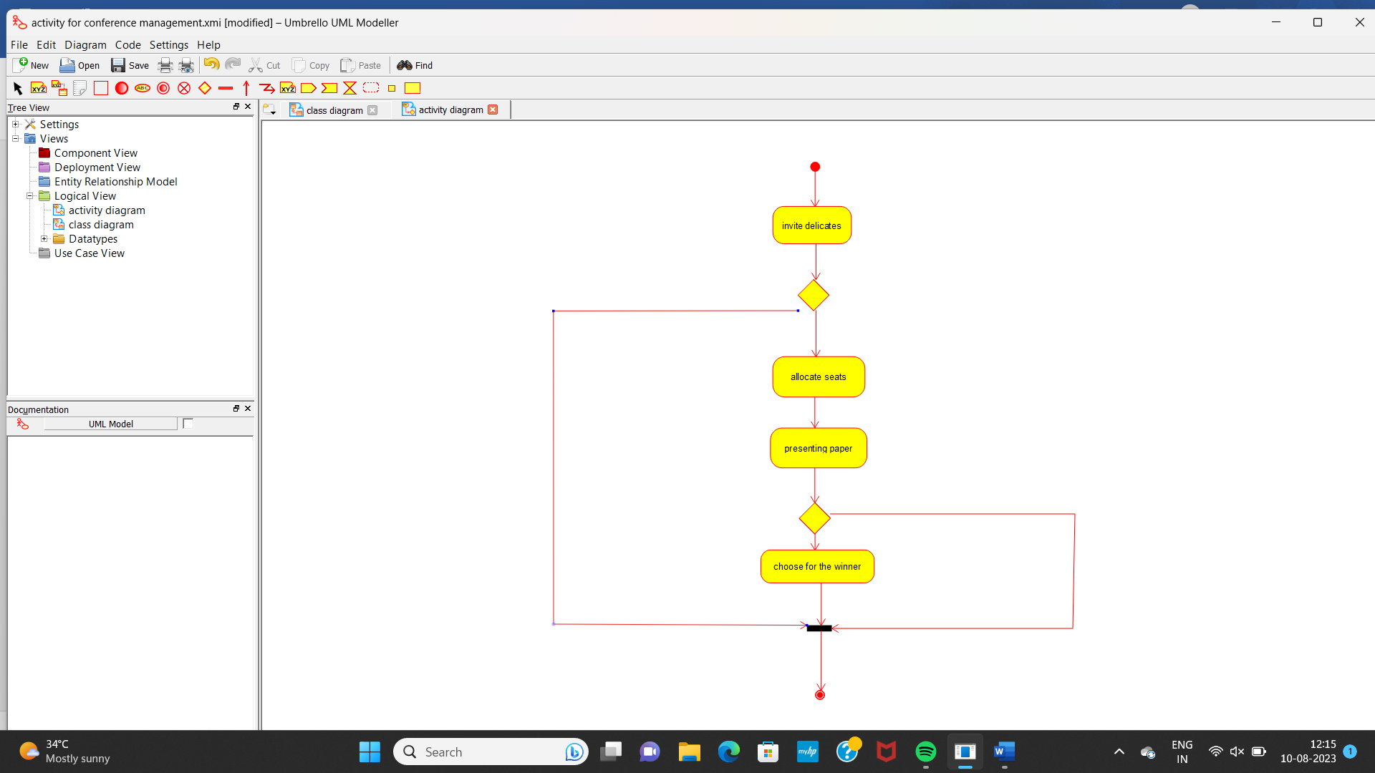

COMMUNICATION DIAGRAM:

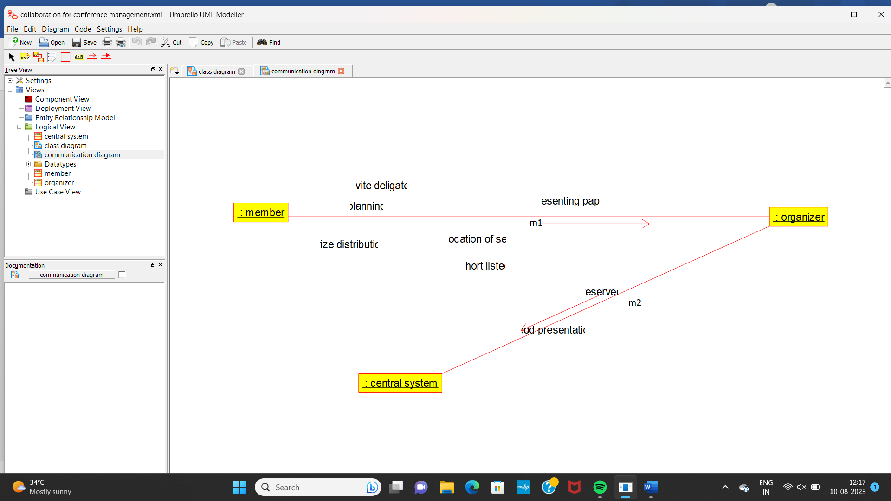

COMPONENT DIAGRAM:

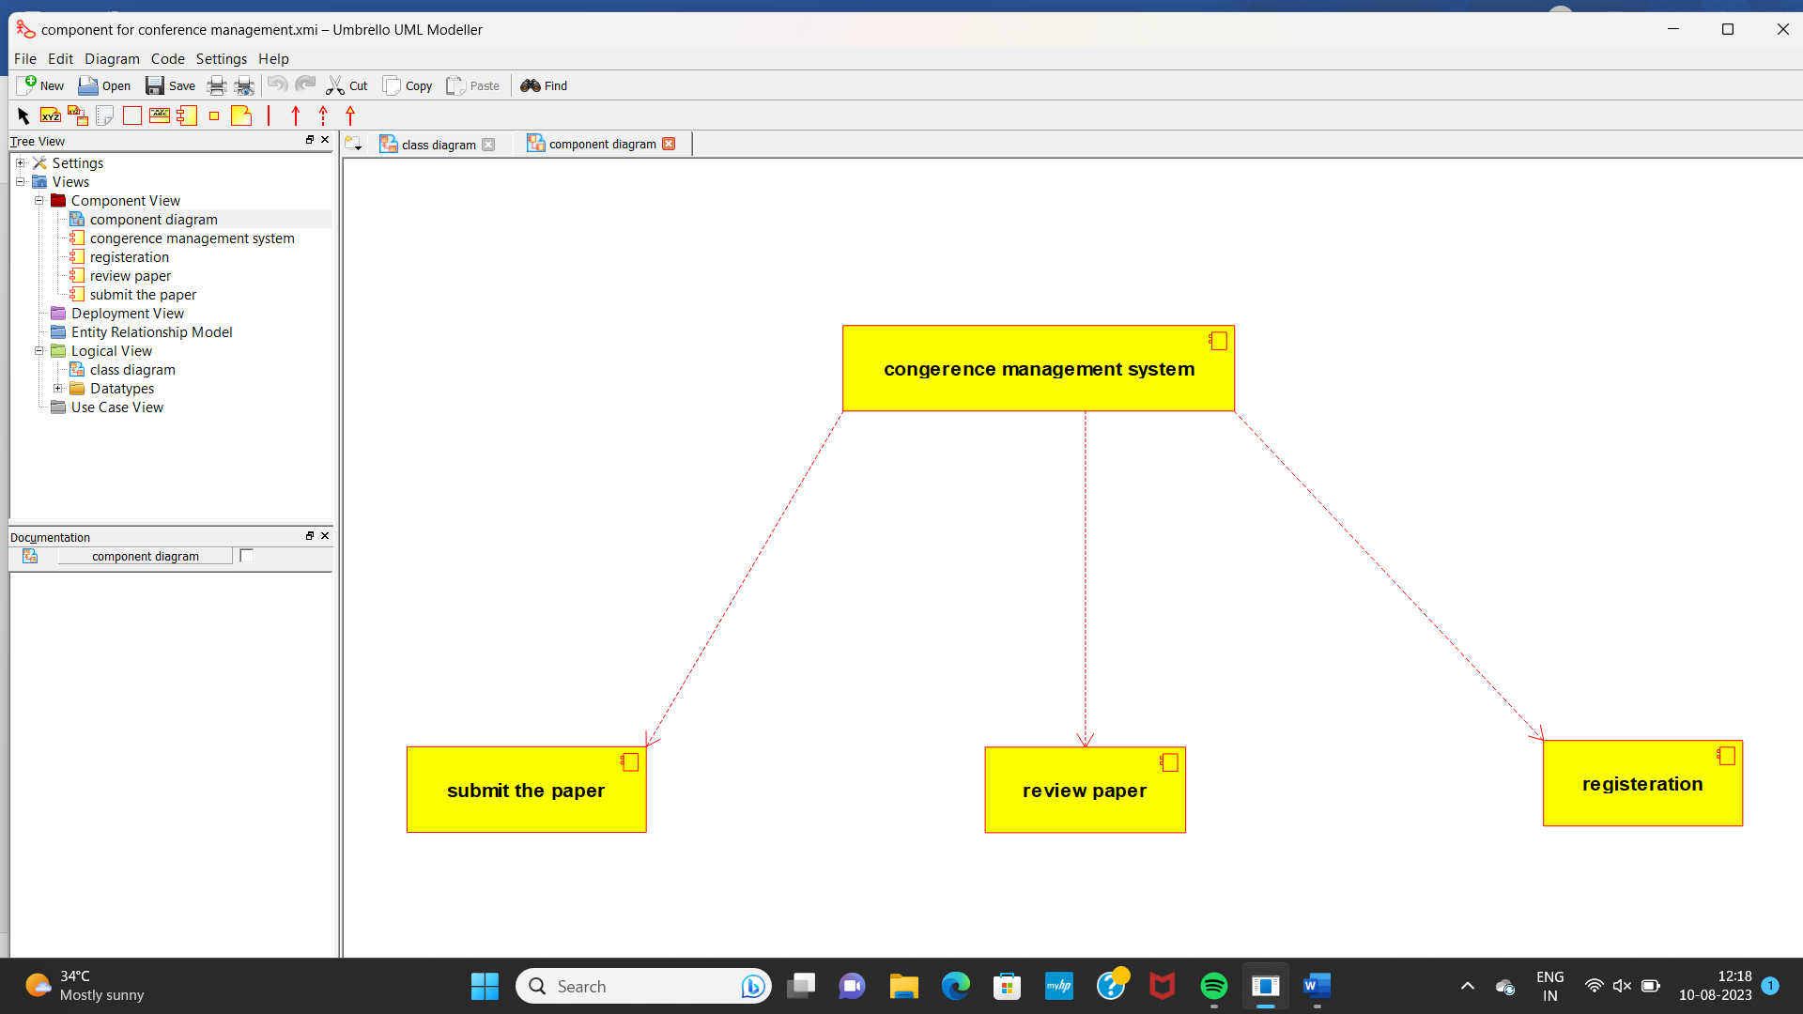

DEPLOYEMENT DIAGRAM:

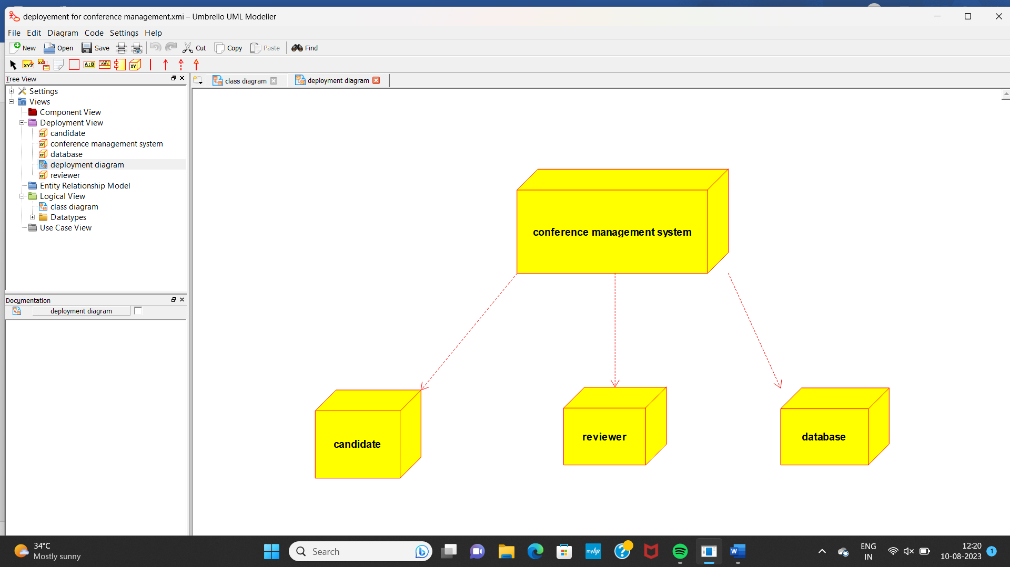

SEQUENCE DIAGRAM:

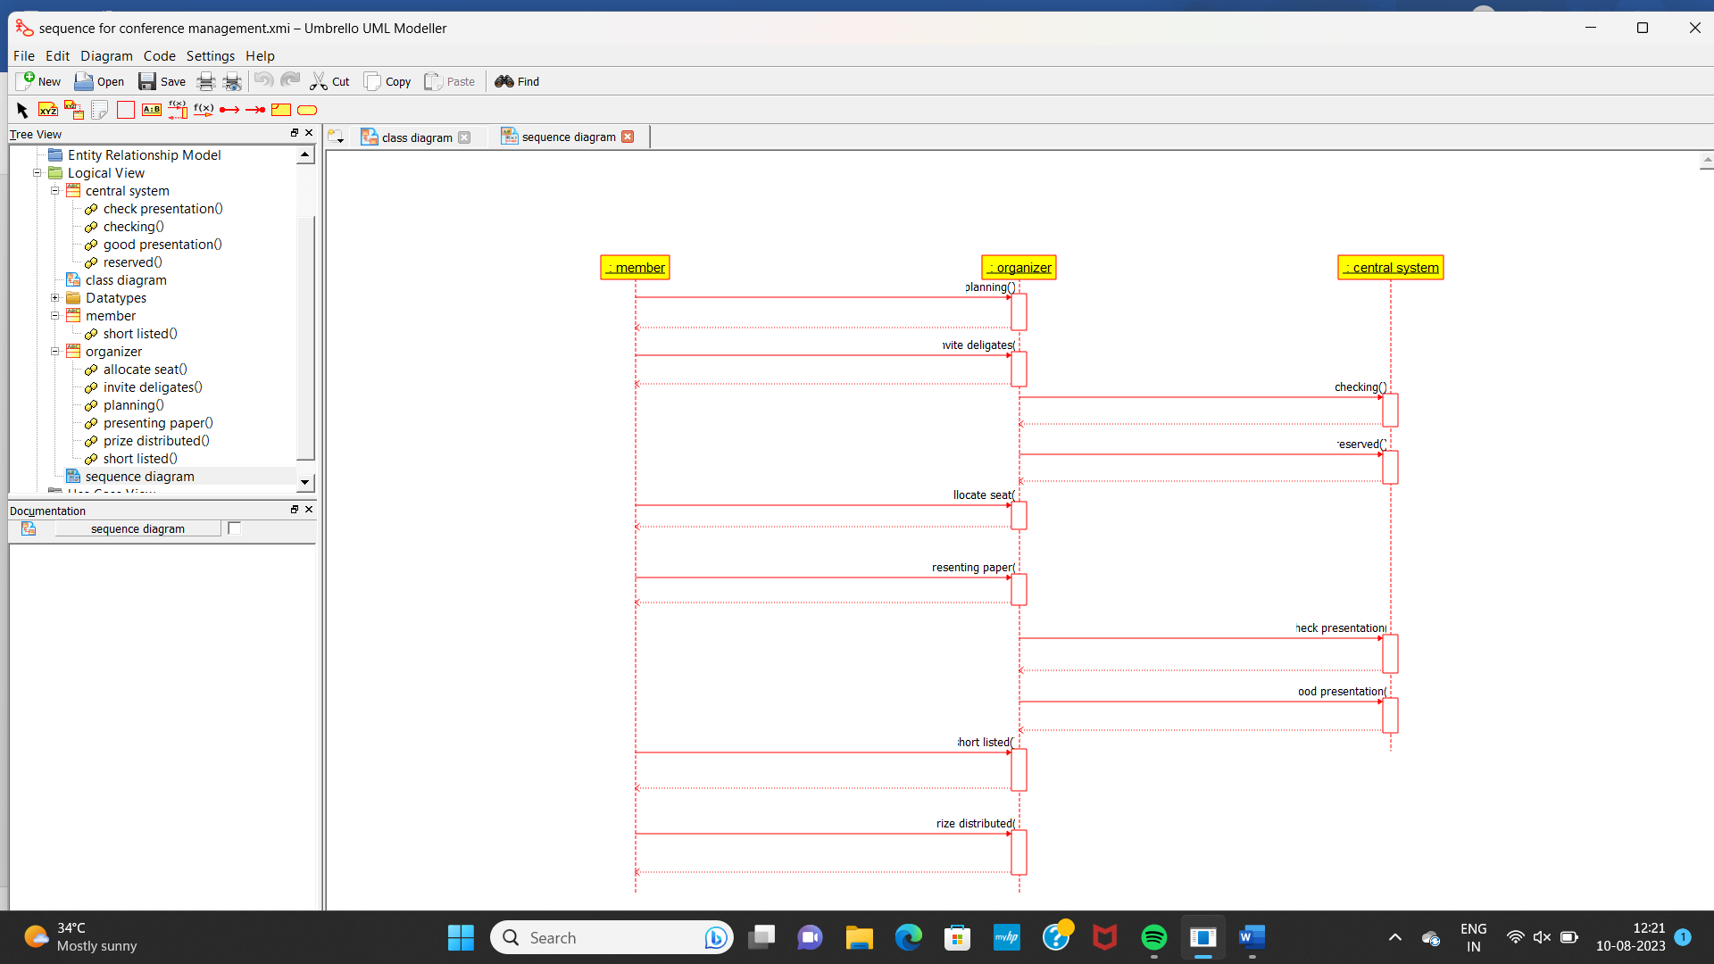

STATE DIAGRAM:

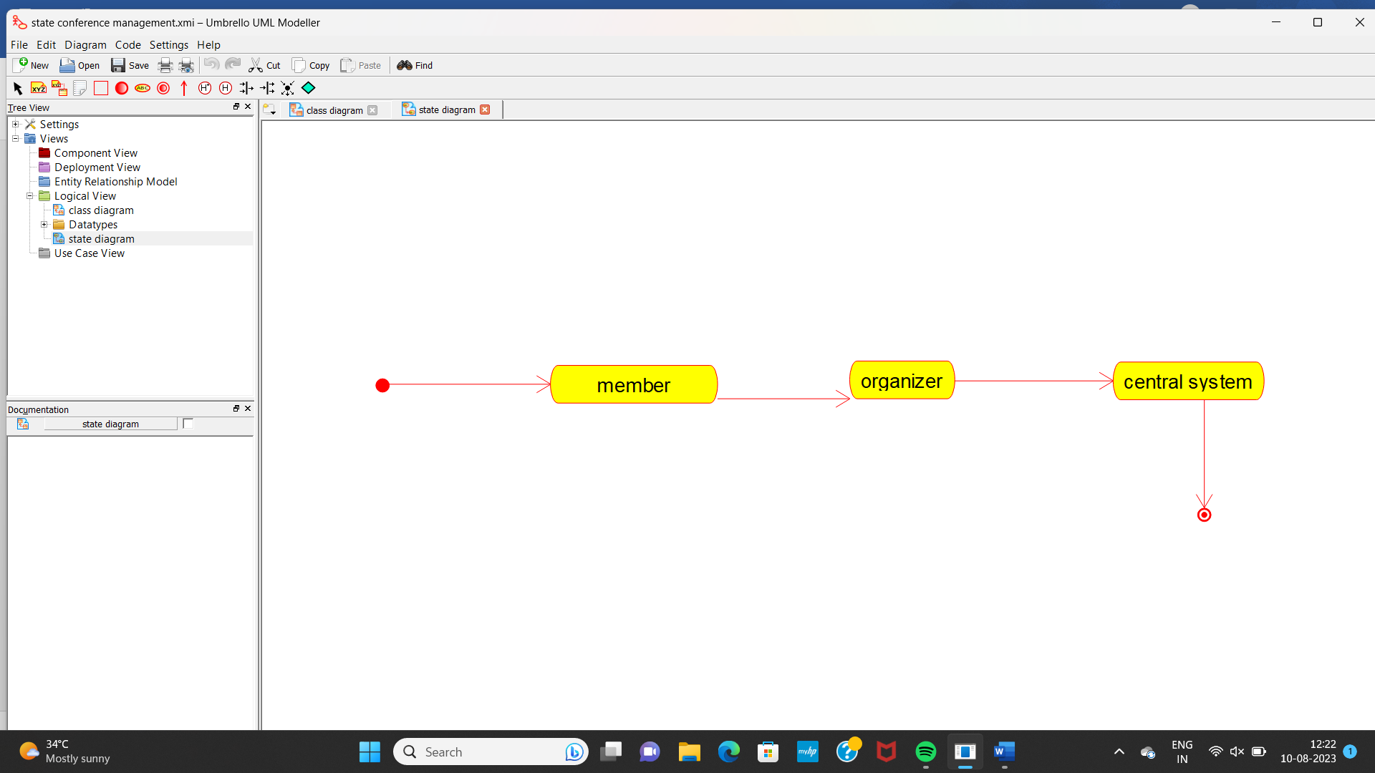

PACKAGE DIAGRAM:

